1. **Create a Spring Web Project using Maven**

**SpringLearnApplication:**

package com.cognizant.spring_learn;

import org.slf4j.Logger;

import org.slf4j.LoggerFactory;

import org.springframework.boot.SpringApplication;

import org.springframework.boot.autoconfigure.SpringBootApplication;

@SpringBootApplication

public class SpringLearnApplication {

private static final Logger LOGGER = LoggerFactory.getLogger(SpringLearnApplication.class);

public static void main(String[] args) {

LOGGER.info("START - SpringLearnApplication");

SpringApplication.run(SpringLearnApplication.class, args);

LOGGER.info("END - SpringLearnApplication");

}

}

**Output :**

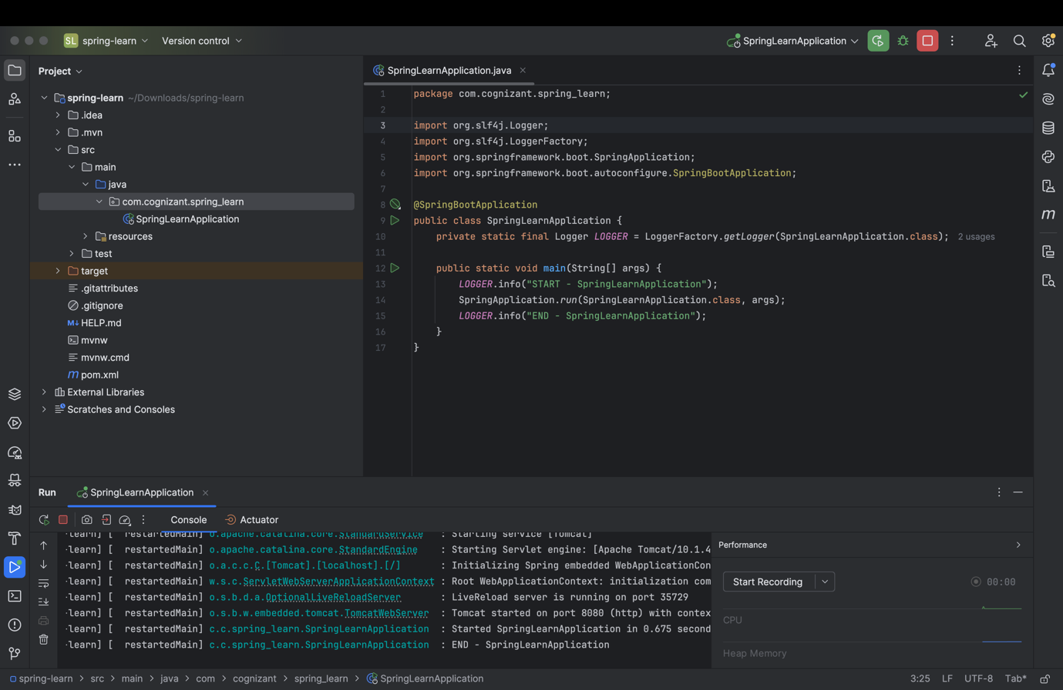

1. **Spring Core – Load Country from Spring Configuration XML**

**Country.xml :**

<?xml version="1.0" encoding="UTF-8"?>

<beans xmlns="http://www.springframework.org/schema/beans"

xmlns:xsi="http://www.w3.org/2001/XMLSchema-instance"

xsi:schemaLocation="http://www.springframework.org/schema/beans

http://www.springframework.org/schema/beans/spring-beans.xsd">

<bean id="country" class="com.cognizant.spring_learn.Country">

<property name="code" value="IN"/>

<property name="name" value="India"/>

</bean>

</beans>

**SpringLearnApplication.java :**

package com.cognizant.spring_learn;

import org.slf4j.Logger;

import org.slf4j.LoggerFactory;

import org.springframework.context.ApplicationContext;

import org.springframework.context.support.ClassPathXmlApplicationContext;

public class SpringLearnApplication {

private static final Logger LOGGER = LoggerFactory.getLogger(SpringLearnApplication.class);

public static void main(String[] args) {

LOGGER.info("START - main()");

displayCountry();

LOGGER.info("END - main()");

}

public static void displayCountry() {

ApplicationContext context = new ClassPathXmlApplicationContext("country.xml");

Country country = context.getBean("country", Country.class);

System.out.println("Country object: " + country);

LOGGER.debug("Country : {}", country.toString());

}

}

**Country.java :**

package com.cognizant.spring_learn;

import org.slf4j.Logger;

import org.slf4j.LoggerFactory;

public class Country {

private static final Logger LOGGER = LoggerFactory.getLogger(Country.class);

private String code;

private String name;

public Country() {

LOGGER.debug("Inside Country Constructor.");

}

public String getCode() {

LOGGER.debug("Inside getCode()");

return code;

}

public void setCode(String code) {

LOGGER.debug("Inside setCode()");

this.code = code;

}

public String getName() {

LOGGER.debug("Inside getName()");

return name;

}

public void setName(String name) {

LOGGER.debug("Inside setName()");

this.name = name;

}

@Override

public String toString() {

return "Country [code=" + code + ", name=" + name + "]";

}

}

**Output :**

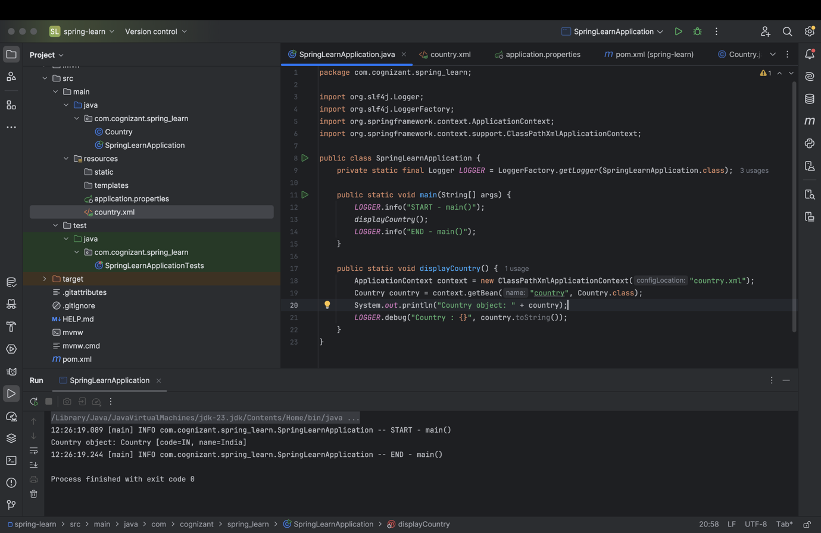

**3.Hello World RESTful Web Service**

**HelloController.java :**

package com.cognizant.spring_learn2.Controller;

import org.springframework.web.bind.annotation.GetMapping;

import org.springframework.web.bind.annotation.RestController;

@RestController

public class HelloController {

@GetMapping("/hello")

public String sayHello() {

String message = "Hello World!!";

return message;

**Output :**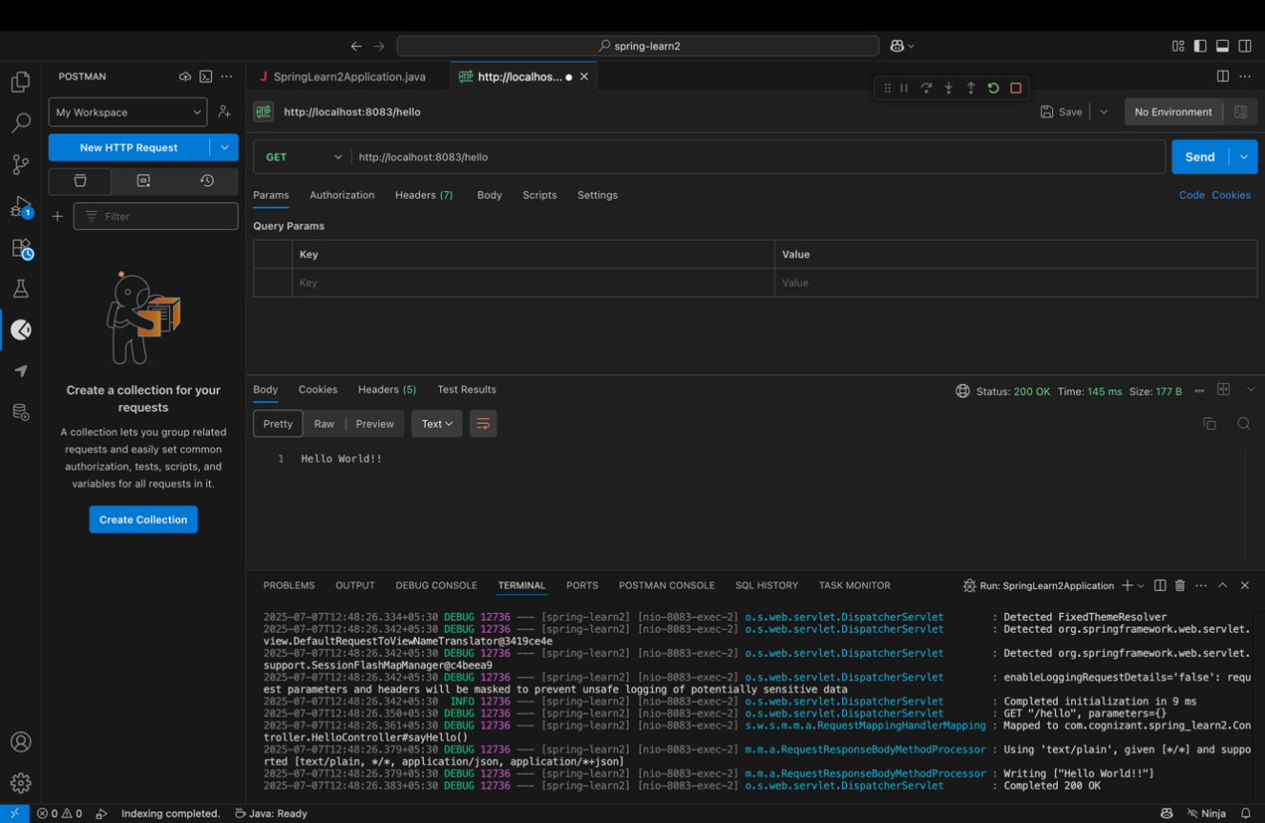

**4.REST - Country Web Service**

**CountryController.java :**

package com.cognizant.spring_learn2.Controller;

import com.cognizant.spring_learn2.Country;

import org.slf4j.Logger;

import org.slf4j.LoggerFactory;

import org.springframework.context.ApplicationContext;

import org.springframework.context.support.ClassPathXmlApplicationContext;

import org.springframework.web.bind.annotation.RequestMapping;

import org.springframework.web.bind.annotation.RestController;

@RestController

public class CountryController {

private static final Logger LOGGER = LoggerFactory.getLogger(CountryController.class);

@RequestMapping("/country")

public Country getCountryIndia() {

LOGGER.info("START - getCountryIndia()");

ApplicationContext context = new ClassPathXmlApplicationContext("country.xml");

Country country = context.getBean("country", Country.class);

LOGGER.info("END - getCountryIndia()");

return country;

}

}

**Country.xml :**

<?xml version="1.0" encoding="UTF-8"?>

<beans xmlns="http://www.springframework.org/schema/beans"

xmlns:xsi="http://www.w3.org/2001/XMLSchema-instance"

xsi:schemaLocation="http://www.springframework.org/schema/beans

http://www.springframework.org/schema/beans/spring-beans.xsd">

<bean id="country" class="com.cognizant.spring_learn2.Country">

<property name="code" value="IN"/>

<property name="name" value="India"/>

</bean>

</beans>

**Output :**

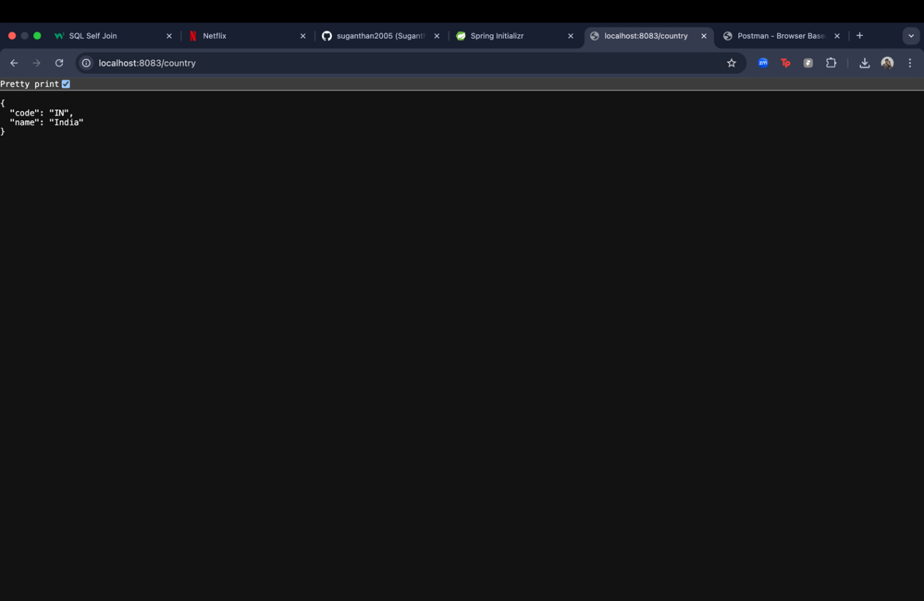

**5.REST - Get country based on country code**

**Country.xml :**

<?xml version="1.0" encoding="UTF-8"?>

<beans xmlns="http://www.springframework.org/schema/beans"

xmlns:xsi="http://www.w3.org/2001/XMLSchema-instance"

xsi:schemaLocation="http://www.springframework.org/schema/beans

http://www.springframework.org/schema/beans/spring-beans.xsd">

<bean id="country" class="com.cognizant.spring_learn2.Country">

<property name="code" value="IN"/>

<property name="name" value="India"/>

</bean>

<bean id="countryList" class="java.util.ArrayList">

<constructor-arg>

<list>

<bean class="com.cognizant.spring_learn2.Country">

<property name="code" value="IN"/>

<property name="name" value="India"/>

</bean>

<bean class="com.cognizant.spring_learn2.Country">

<property name="code" value="US"/>

<property name="name" value="United States"/>

</bean>

<bean class="com.cognizant.spring_learn2.Country">

<property name="code" value="DE"/>

<property name="name" value="Germany"/>

</bean>

<bean class="com.cognizant.spring_learn2.Country">

<property name="code" value="JP"/>

<property name="name" value="Japan"/>

</bean>

</list>

</constructor-arg>

</bean>

</beans>

**Country.java :**

package com.cognizant.spring_learn2;

import org.slf4j.Logger;

import org.slf4j.LoggerFactory;

public class Country {

private static final Logger LOGGER = LoggerFactory.getLogger(Country.class);

private String code;

private String name;

public Country() {

LOGGER.debug("Inside Country Constructor.");

}

public String getCode() {

LOGGER.debug("Inside getCode()");

return code;

}

public void setCode(String code) {

LOGGER.debug("Inside setCode()");

this.code = code;

}

public String getName() {

LOGGER.debug("Inside getName()");

return name;

}

public void setName(String name) {

LOGGER.debug("Inside setName()");

this.name = name;

}

@Override

public String toString() {

return "Country [code=" + code + ", name=" + name + "]";

}

}

**CountryController.java :**

package com.cognizant.spring_learn2.Controller;

import com.cognizant.spring_learn2.Country;

import com.cognizant.spring_learn2.service.CountryService;

import org.slf4j.Logger;

import org.slf4j.LoggerFactory;

import org.springframework.beans.factory.annotation.Autowired;

import org.springframework.web.bind.annotation.*;

@RestController

public class CountryController {

private static final Logger LOGGER = LoggerFactory.getLogger(CountryController.class);

@Autowired

private CountryService countryService;

@GetMapping("/country/{code}")

public Country getCountry(@PathVariable String code) {

LOGGER.info("START - getCountry(): {}", code);

Country country = countryService.getCountry(code);

LOGGER.info("END - getCountry()");

return country;

}

}

**CountryService.java :**

package com.cognizant.spring_learn2.service;

import com.cognizant.spring_learn2.Country;

import org.springframework.context.ApplicationContext;

import org.springframework.context.support.ClassPathXmlApplicationContext;

import org.springframework.stereotype.Service;

import java.util.List;

@Service

public class CountryService {

public Country getCountry(String code) {

ApplicationContext context = new ClassPathXmlApplicationContext("country.xml");

List<Country> countryList = context.getBean("countryList", List.class);

return countryList.stream()

.filter(c -> c.getCode().equalsIgnoreCase(code))

.findFirst()

.orElseThrow(() -> new RuntimeException("Country not found: " + code));

}

}

**Output :**

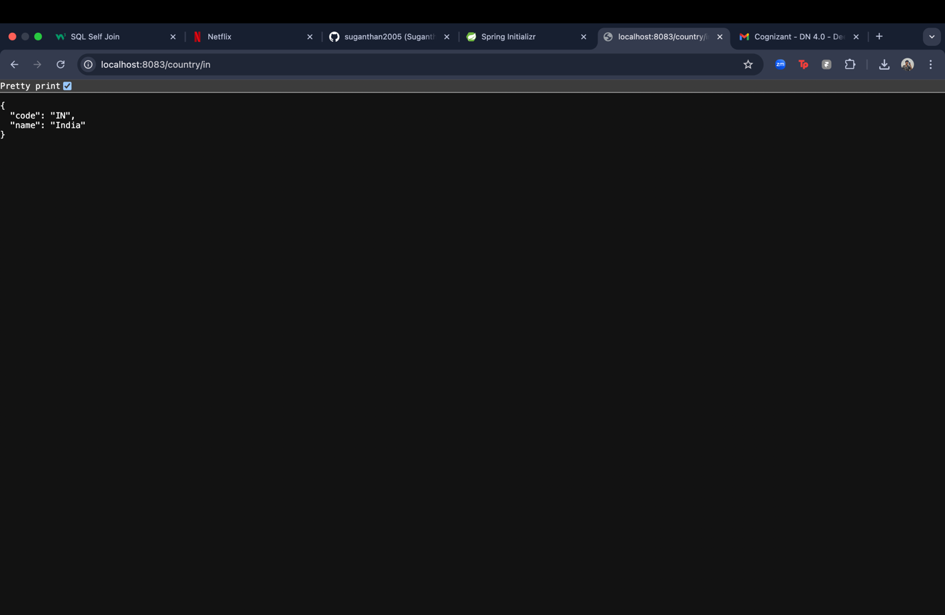

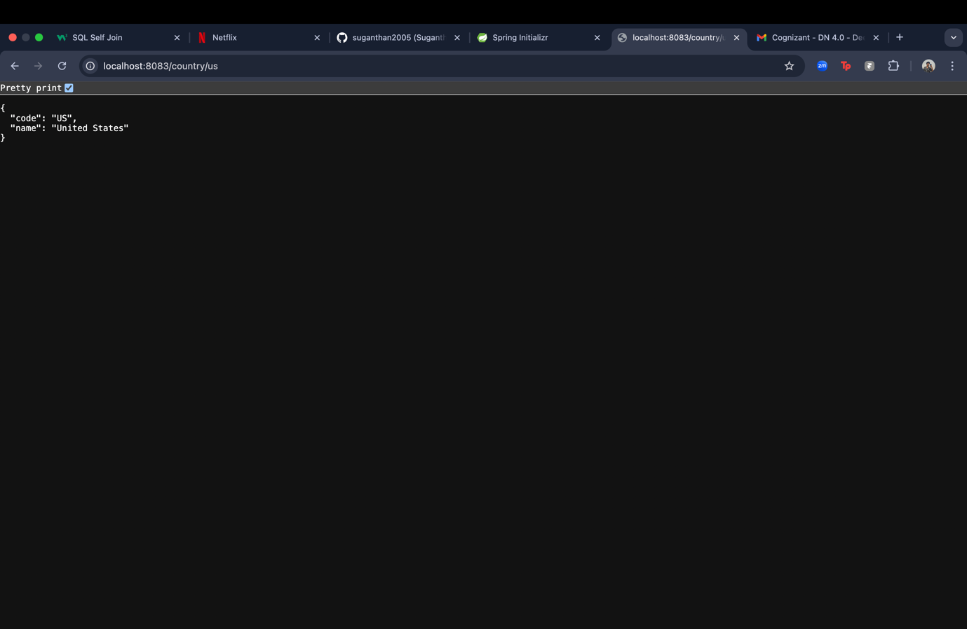

**6.Create authentication service that returns JWT**

**JwtUtil.java :**

package com.cognizant.spring_learn2.util;

import java.util.Date;

import org.springframework.stereotype.Component;

import io.jsonwebtoken.Jwts;

import io.jsonwebtoken.SignatureAlgorithm;

@Component

public class JwtUtil {

private final String secretKey = "mysecretkey";

public String generateToken(String username)

return Jwts.builder()

.setSubject(username)

.setIssuedAt(new Date(System.currentTimeMillis()))

.setExpiration(new Date(System.currentTimeMillis() + 1000 * 60 * 60 * 10))

.signWith(SignatureAlgorithm.HS256, secretKey)

.compact();

}

}

**AuthenticationController.java :**

package com.cognizant.spring_learn2.Controller;

import java.util.Base64;

import java.util.HashMap;

import java.util.Map;

import org.slf4j.Logger;

import org.slf4j.LoggerFactory;

import org.springframework.web.bind.annotation.GetMapping;

import org.springframework.web.bind.annotation.RequestHeader;

import org.springframework.web.bind.annotation.RestController;

import com.cognizant.spring_learn2.util.JwtUtil;

@RestController

public class AuthenticationController {

private static final Logger LOGGER = LoggerFactory.getLogger(AuthenticationController.class);

private final JwtUtil jwtUtil;

public AuthenticationController(JwtUtil jwtUtil) {

this.jwtUtil = jwtUtil;

}

@GetMapping("/authenticate")

public Map<String, String> authenticate(@RequestHeader("Authorization") String authHeader) {

LOGGER.info("START - authenticate()");

if (authHeader == null || !authHeader.startsWith("Basic ")) {

throw new RuntimeException("Missing or invalid Authorization header");

}

String[] credentials = new String(Base64.getDecoder()

.decode(authHeader.substring("Basic ".length())))

.split(":");

String username = credentials[0];

String password = credentials[1];

if (!username.equals("user") || !password.equals("pwd")) {

throw new RuntimeException("Invalid credentials");

}

String token = jwtUtil.generateToken(username);

Map<String, String> response = new HashMap<>();

response.put("token", token);

LOGGER.info("END - authenticate()");

return response;

}

}

**SecurityConfig.java :**

package com.cognizant.spring_learn2.config;

import org.springframework.context.annotation.Bean;

import org.springframework.context.annotation.Configuration;

import org.springframework.security.config.annotation.web.configuration.EnableWebSecurity;

import org.springframework.security.web.SecurityFilterChain;

import org.springframework.security.config.annotation.web.builders.HttpSecurity;

@EnableWebSecurity

@Configuration

public class SecurityConfig {

@Bean

public SecurityFilterChain filterChain(HttpSecurity http) throws Exception {

.csrf(csrf -> csrf.disable())

.authorizeHttpRequests(auth -> auth

.requestMatchers("/authenticate").permitAll()

.anyRequest().authenticated()

)

.httpBasic(); // Enable basic auth

return http.build();

}

}

**Output:**

